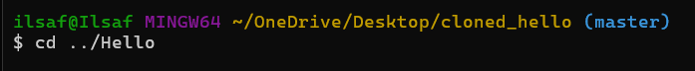

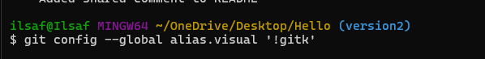

w

